Study Highlights Genetic Diversity of VA’s Million Veterans Program
July 22, 2024
Latest MVP study represents one of the largest studies of its kind to look at genetic associations with health-related traits and disease among a diverse population
David Raths
Photo 116289032 © Jonathan Weiss | Dreamstime.com

A study recently published in Science on the impact of VA’s Million Veterans Program (MVP) underscores the importance of diverse representation in genetic research and paves the way for advances in healthcare tailored to meet individual veteran and veteran population-specific needs.
MVP is a national research program looking at how genes, lifestyle, military experiences, and exposures affect health and wellness in veterans.
Since launching in 2011, 1 million veterans have joined MVP. It's the largest research effort at VA to improve healthcare for veterans and one of the largest research programs in the world studying genes and health. More than 250,000 minority veterans and 100,000 women veterans have joined the program, and MVP includes more people of African ancestry than any research program in the world. This allows researchers to learn more about — and ultimately treat — populations that have historically been underrepresented in research.
Led by VA physicians Scott Damrauer and Katherine Liao and a team of VA researchers, in partnership with U.S. Department of Energy researchers and the National Institutes of Health (NIH) National Library of Medicine, the latest MVP study included 635,969 veterans and represented one of the largest studies of its kind to look at genetic associations with health-related traits and disease among a diverse population.
According to the VA, a persistent limitation of clinical research is a lack of diversity among study participants. The implications are that research findings may not apply to all populations. For instance, certain genetic traits and their associated diseases may be more common in some populations than others. When a study’s participants are alike in their demographics, these important differences go unrecognized. In contrast, when studies include individuals from diverse backgrounds, researchers can pinpoint these unique differences and tailor the study’s implications accordingly.
This is what sets the study that was published today apart from others. Nearly one-third (n=186,927) of veteran participants were of non-European ancestry. In comparison, across all genome-wide association studies published to-date, nearly 94% of participants were of European ancestry. The diversity of this study enabled the identification of nearly 3,500 associations made possible only because non-European populations were included.
Diversity is what makes MVP such a powerful tool, driving its ability to generate research findings that will improve care for all veterans. Of MVP’s more than a million participants, over a quarter represent a racial or ethnic minority. This makes MVP one of the most diverse genetic databases in the world.
A primary goal of this study was to assess the relationship between genetic variations (i.e., differences in genes between individuals) and various health traits and diseases (e.g., diabetes, blood cell counts, etc.). By assessing the DNA of veteran participants and linking findings to VA medical records and additional research questionnaires, the research team identified a total of 26,049 associations between genetic variations and traits across a total of 1,270 health traits. Overall, researchers identified that the genes that cause diseases are more similar than different across veterans from all backgrounds. Notably, a method called fine-mapping identified causal variants at 6,318 signals across 613 traits. Of these, a third of the associations (n=2,069) identified were unique to populations of non-European ancestry due largely to diseases that are more prevalent or genetic variants that are more common in one group than another.
Some of the key findings include:
• Identification of 101 traits in Veterans with African ancestry that exhibit a prevalence at least twice as high as that observed in Veterans of European ancestry, including hereditary hemolytic anemias, sarcoidosis and keloid scarring.
• Discovery of a new signal in Veterans with African ancestry associated with increased risk of gout.
• Identification of new genes that are associated with alopecia based on increased prevalence of this condition in the Hispanic Veteran population.
Associations like those identified in this study may represent genetic predispositions to certain health conditions. They may also provide indication of why one veteran may respond differently than another to the same treatment for the same condition. Findings can also help identify new uses for FDA-approved drugs for various diseases and health conditions.
In the past year, the findings from more than 100 studies have been published, highlighting new discoveries on conditions such as tinnitus, Alzheimer’s disease, prostate cancer, PTSD, endometriosis and more. These research findings continue to advance VA’s understanding of and ability to address veterans’ most pressing health concerns and needs.

CONTINUE READING

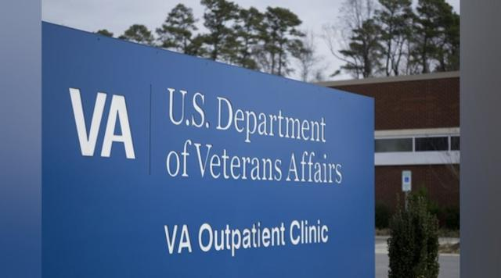

Moving Toward a Learning Health System at the VA

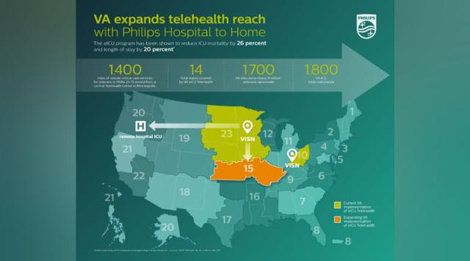

Expanding veterans’ care access with tele-ICU

SPONSORED RECOMMENDATIONS

